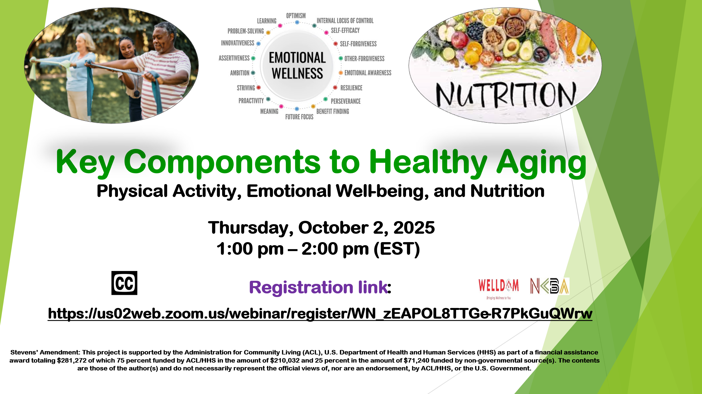

REGISTRATION LINK: <https://us02web.zoom.us/webinar/register/WN_zEAPOL8TTGe-R7PkGuQWrw>