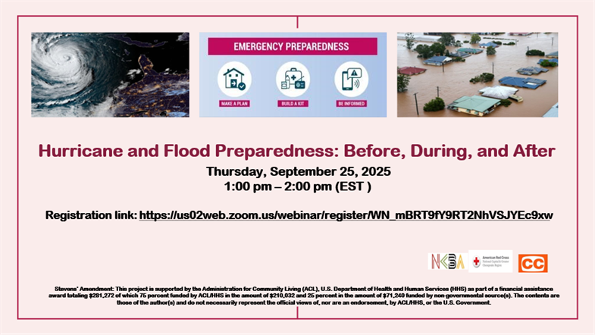

**REGISTRATION LINK:**

<https://us02web.zoom.us/webinar/register/WN_mBRT9fY9RT2NhVSJYEc9xw>