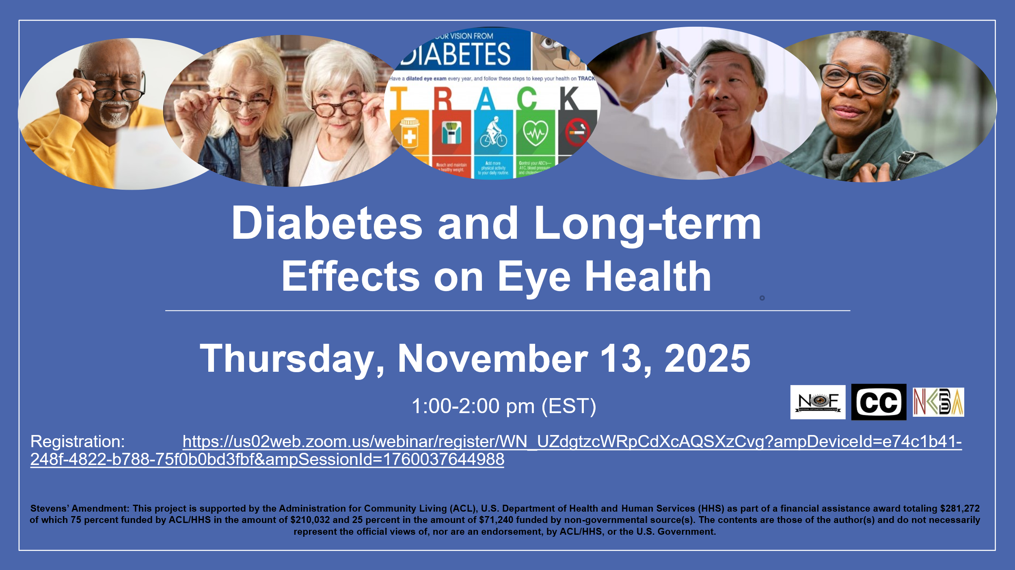

Registration Link: https://us02web.zoom.us/webinar/register/WN_UZdgtzcWRpCdXcAQSXzCvg?ampDeviceId=e74c1b41-248f-4822-b788-75f0b0bd3fbf&ampSessionId=1760037644988

